V—51:(App Overview):

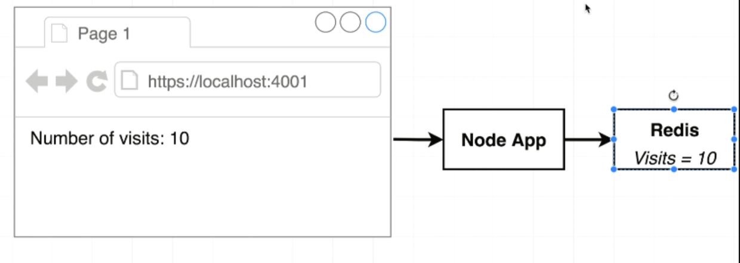

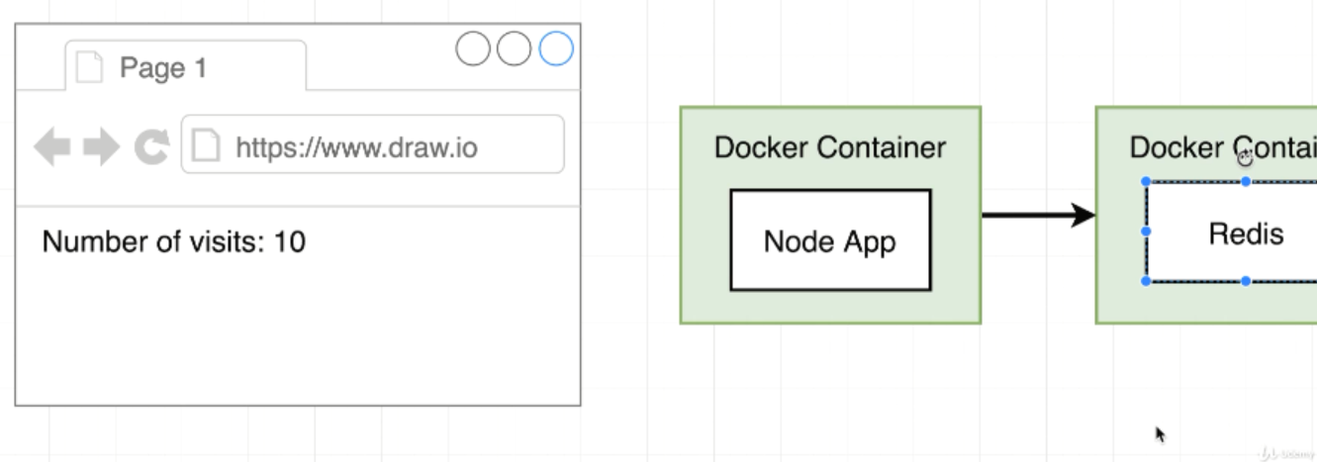

V—52:(App Server Starter Code):

This reddis dependency is a javascript client library for connecting to a reddis server.

Connect to the server and pull information from it and update information inside it as well

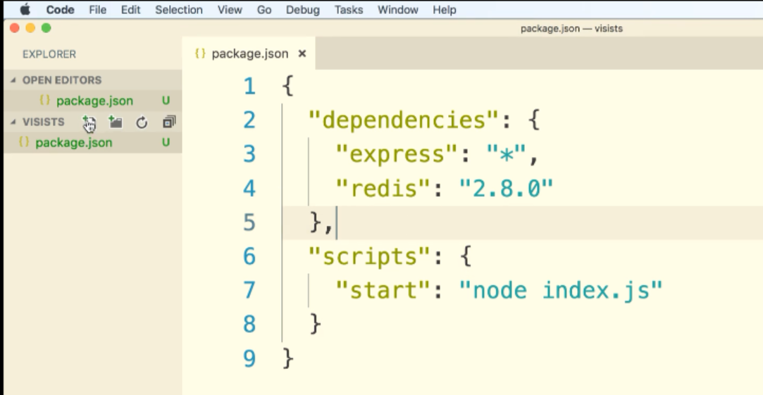

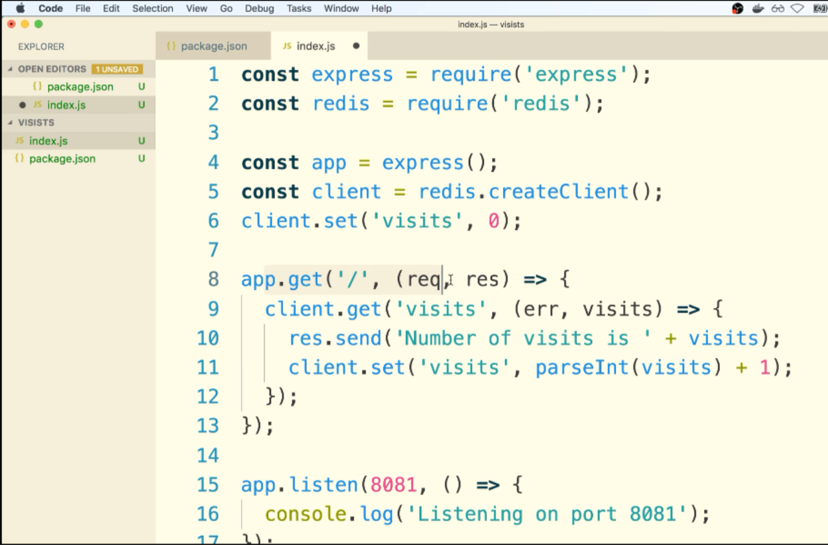

V—53:(Assembling a Docker File):

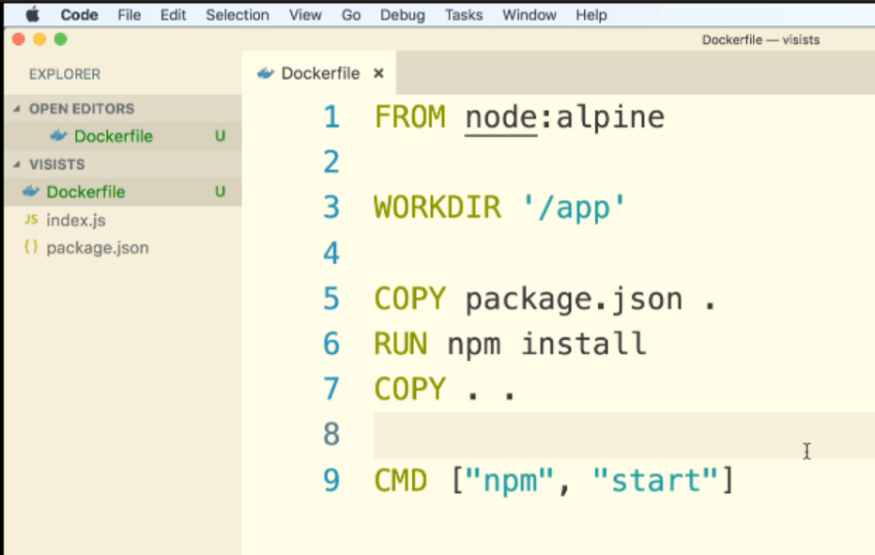

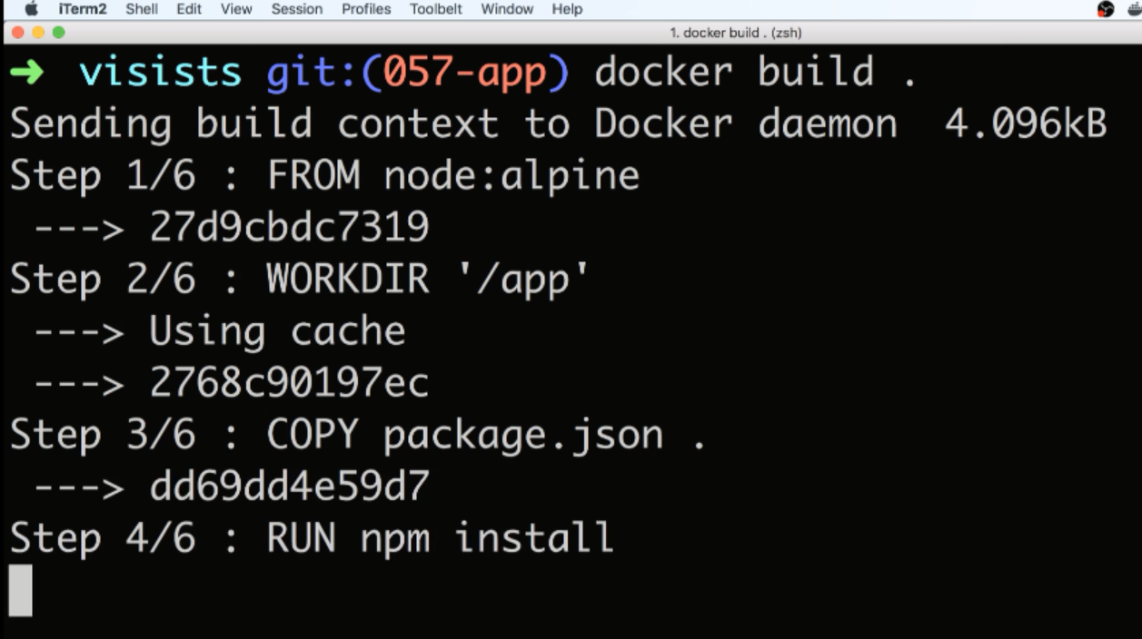

To tag name to the container:

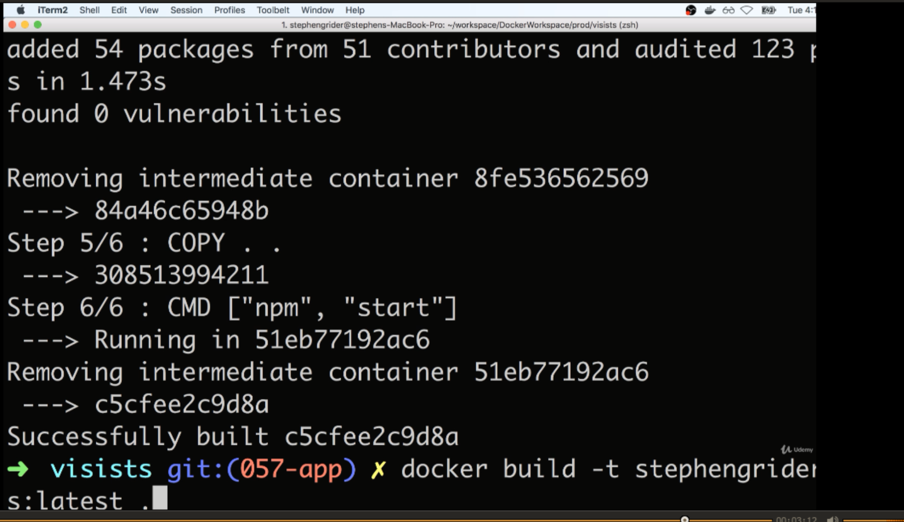

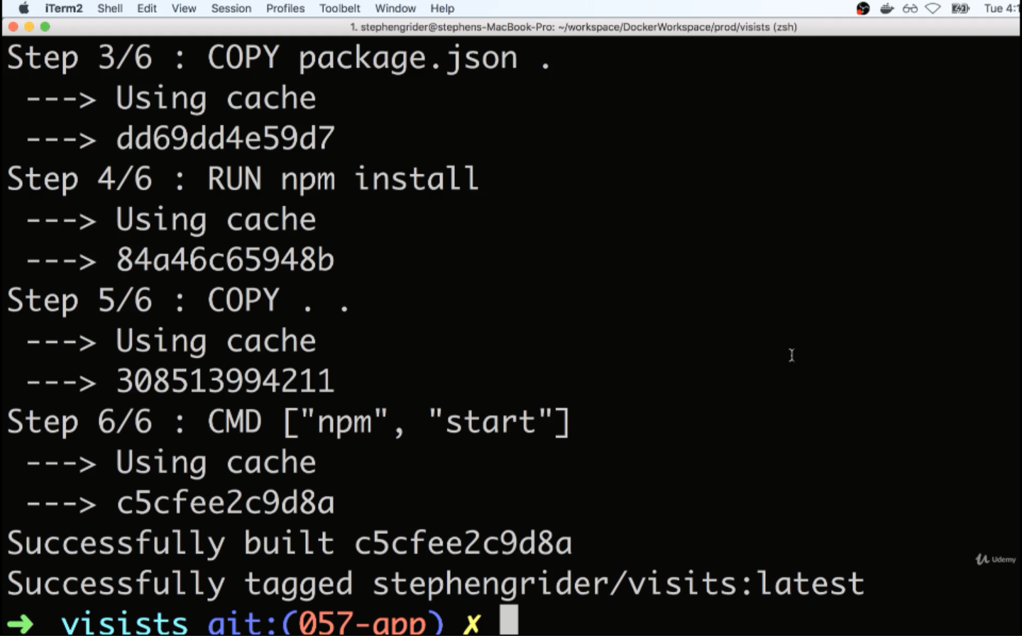

V—54:(Introducing docker Compose):

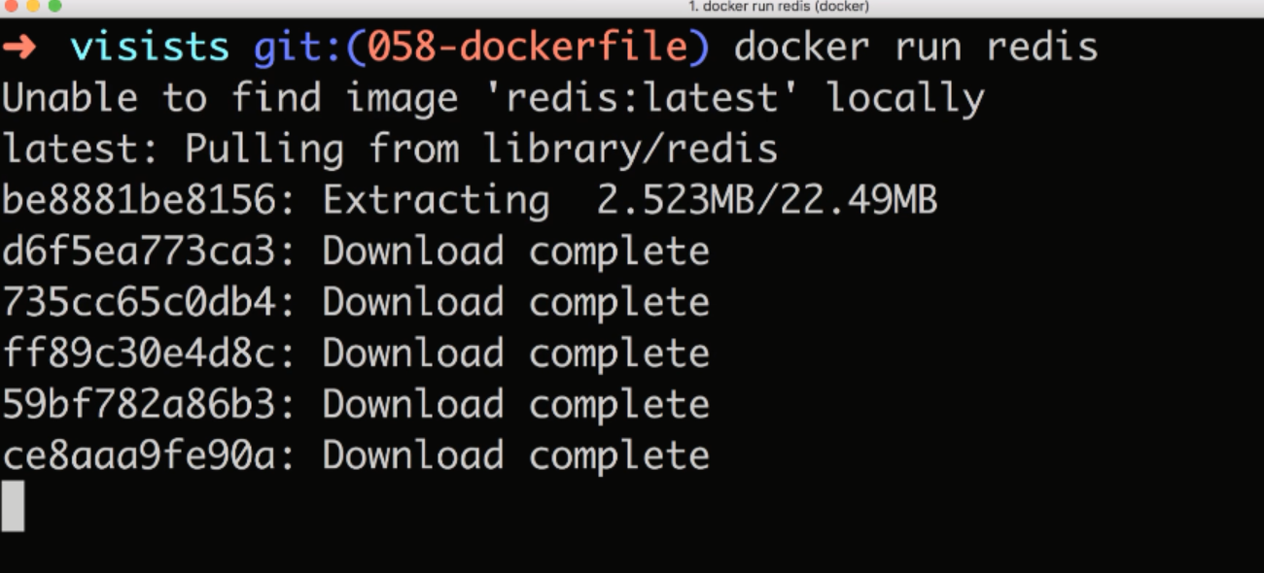

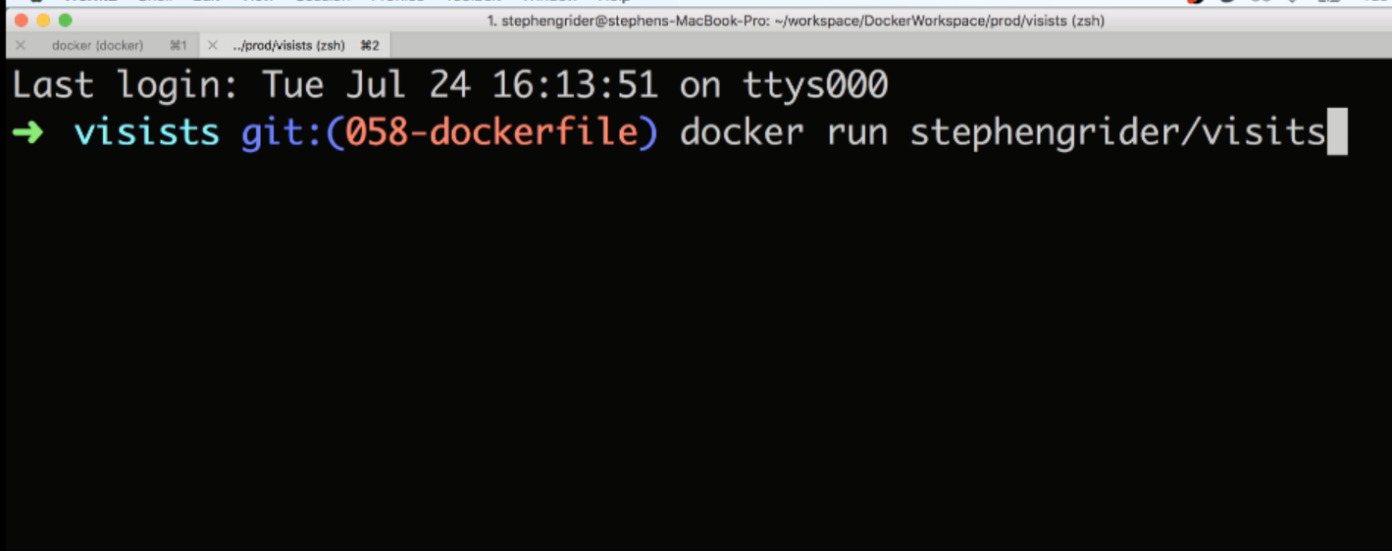

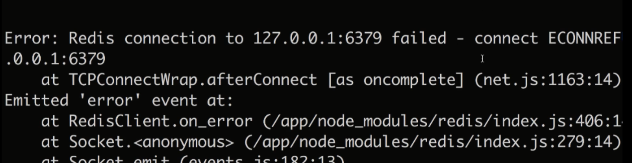

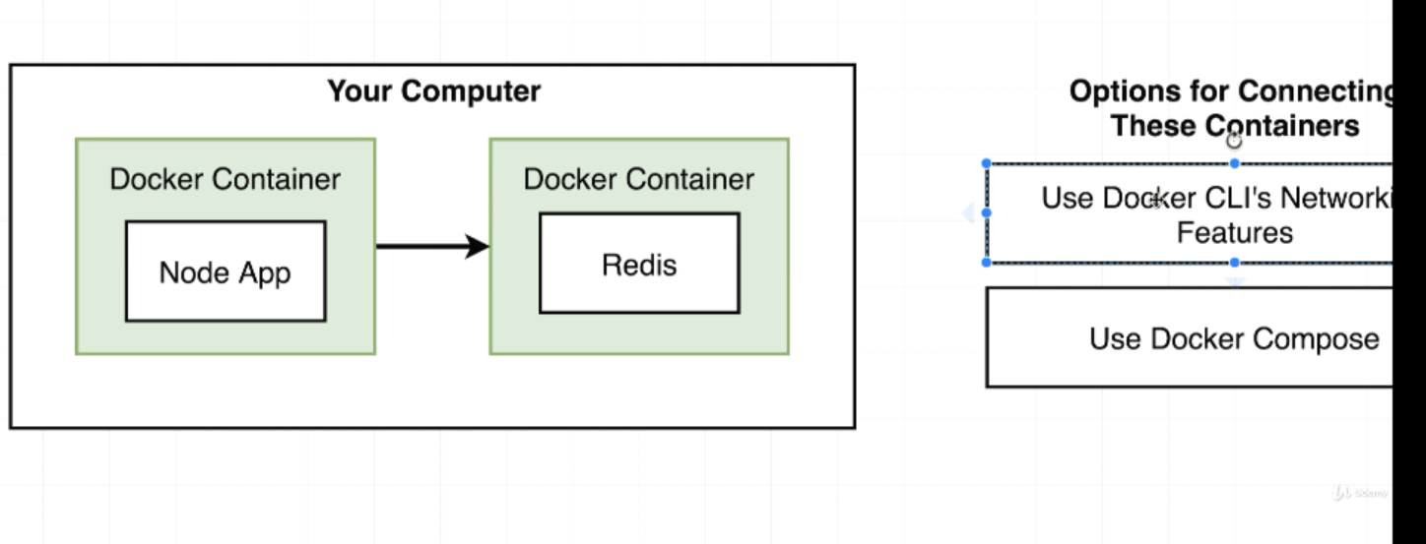

These two containers don’t have any automatic communication. They are two absolutely isolated process that don’t have any communication. We need to set up some networking functionality between those two. 1.Docker cli and docker compose

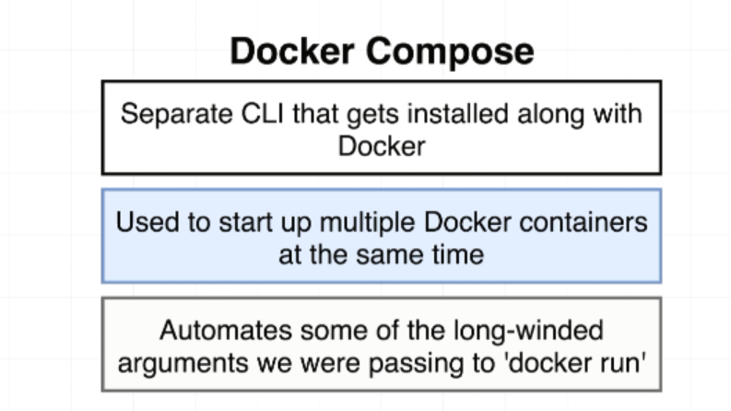

Docker compose exists to keep us from having to write out a ton of different repetitive commands with the Docker CLI

V-55:(Docker Compose Files):

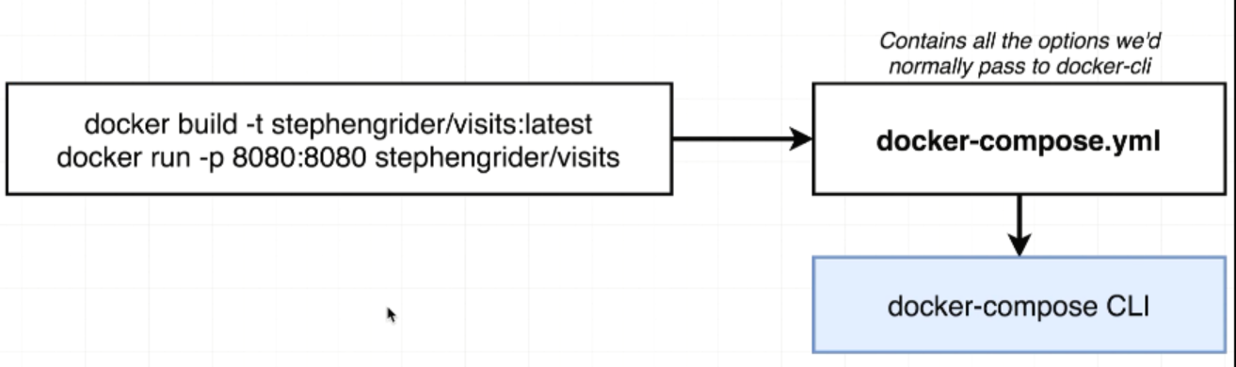

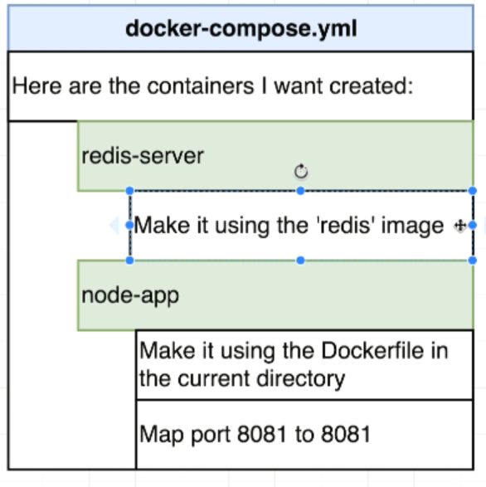

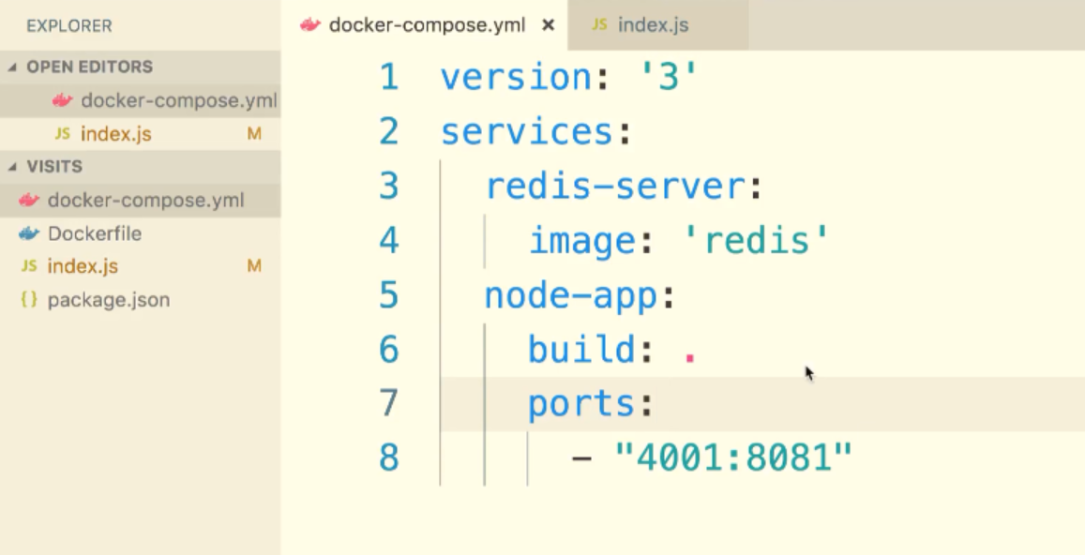

V—56:(Networking with Docker Compose):

By just saying docker compose to create container one and two. They both have free access to each other and can exchange as much information as they want without having to exchange or open up any ports between the two containers

Connect to reddis server in index.js:

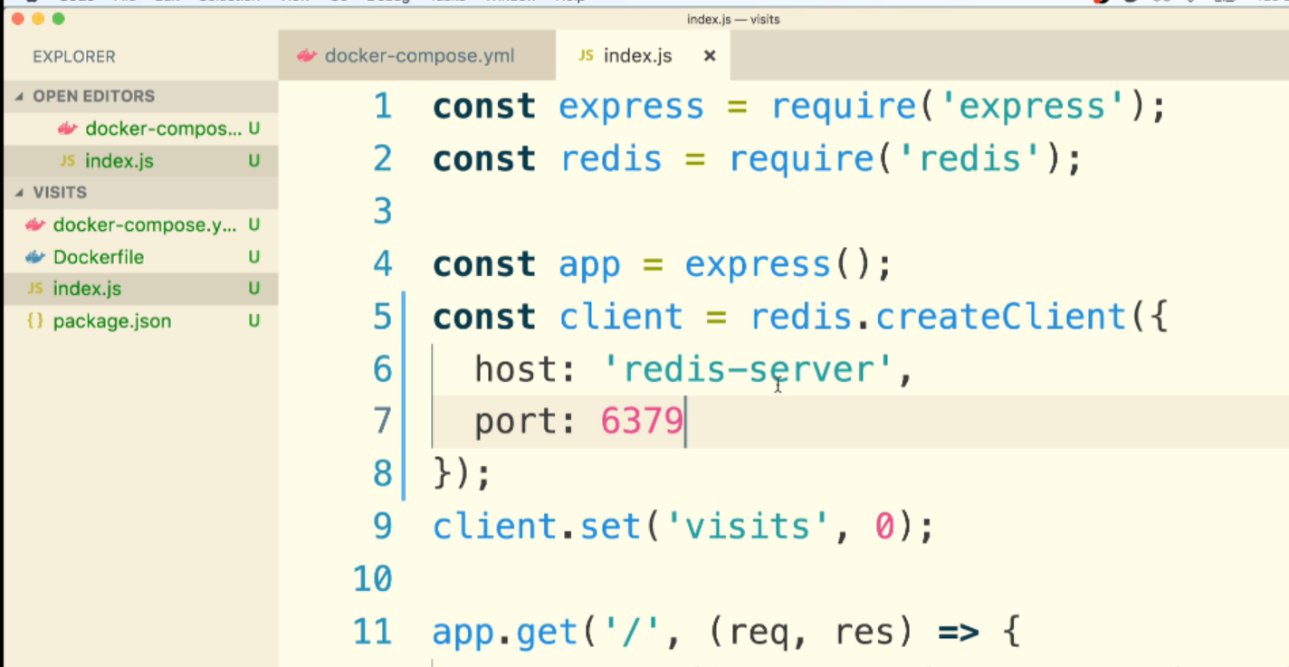

V—57:(Docker Compose Commands):

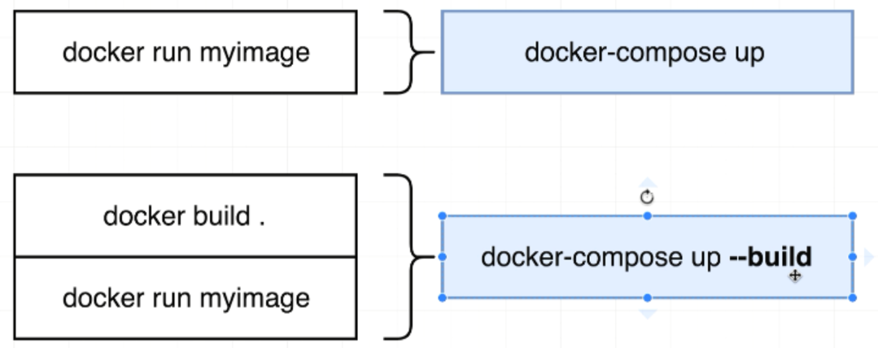

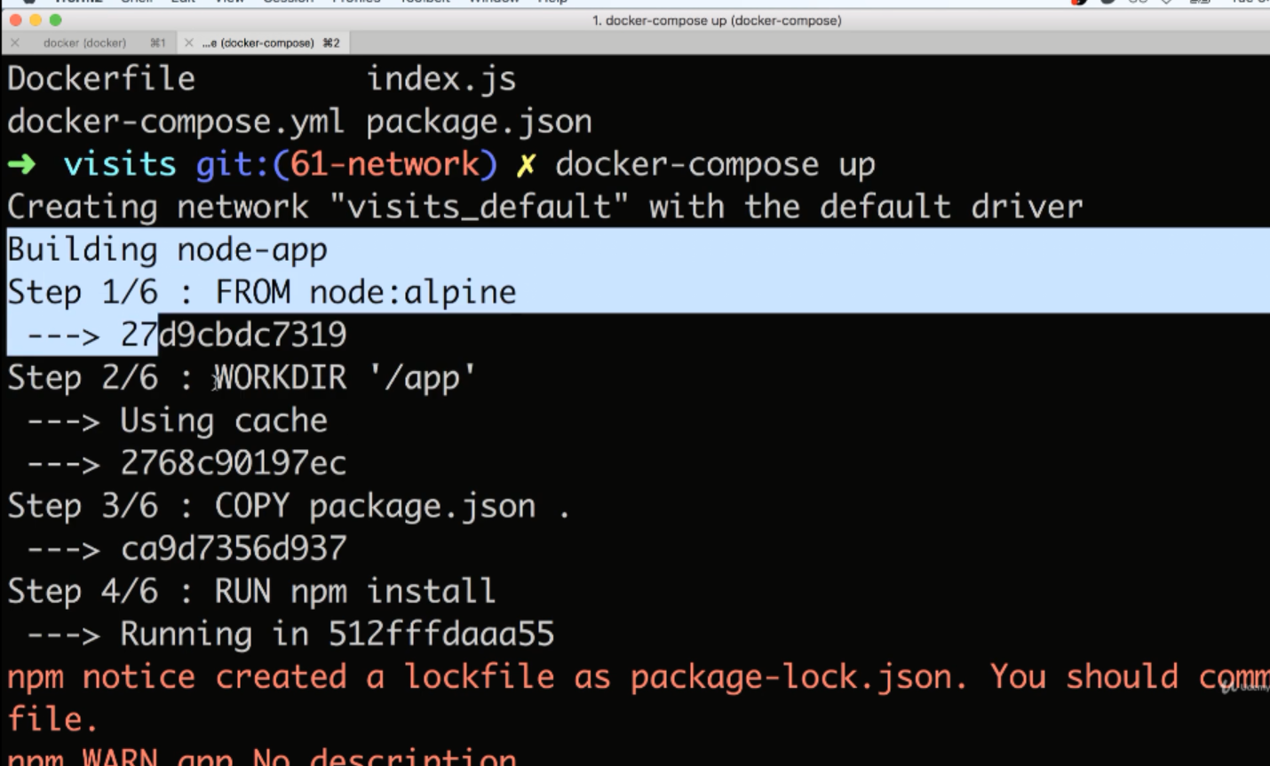

V—58:(Stopping Docker Compose Containers):

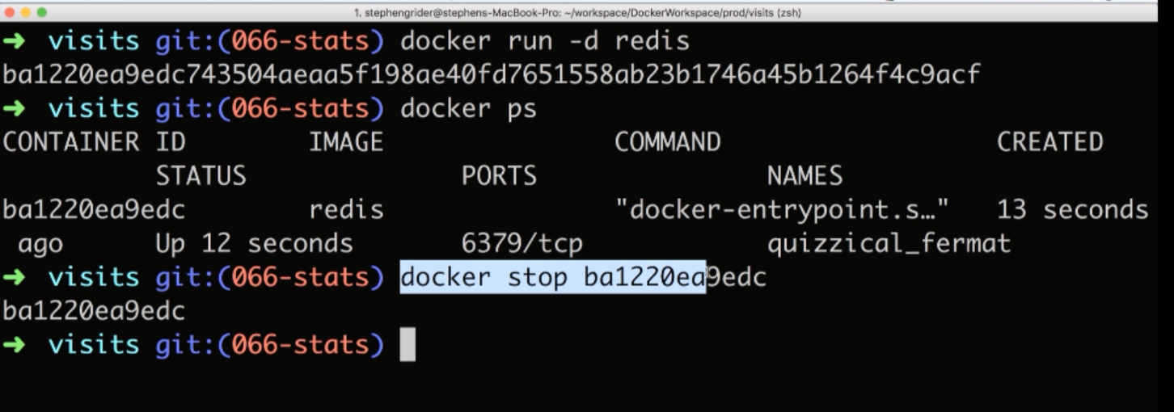

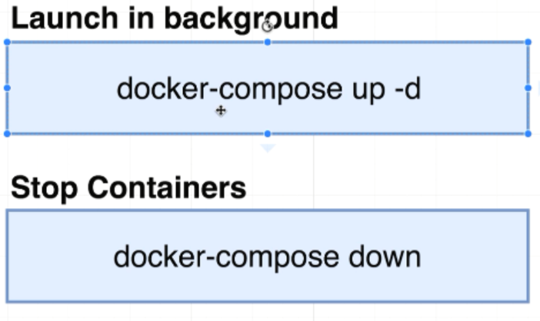

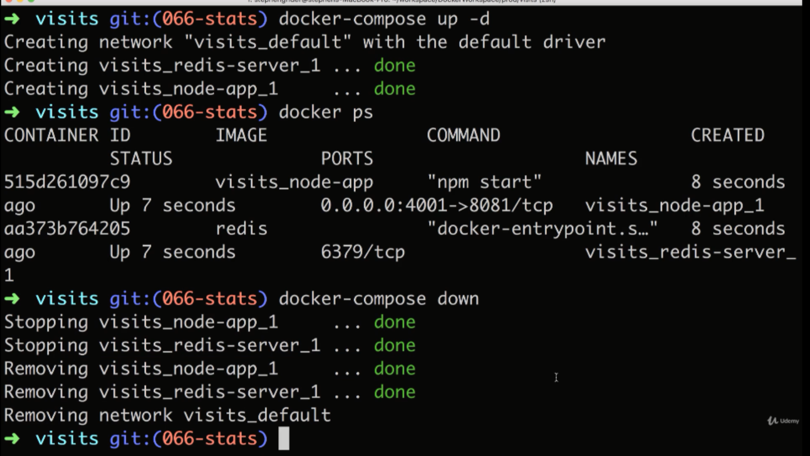

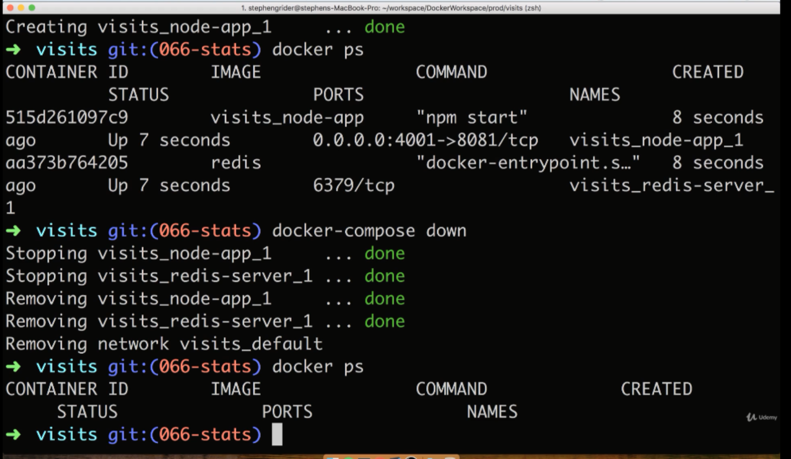

V—59:(Container maintenance with Compose):

Add line 3:

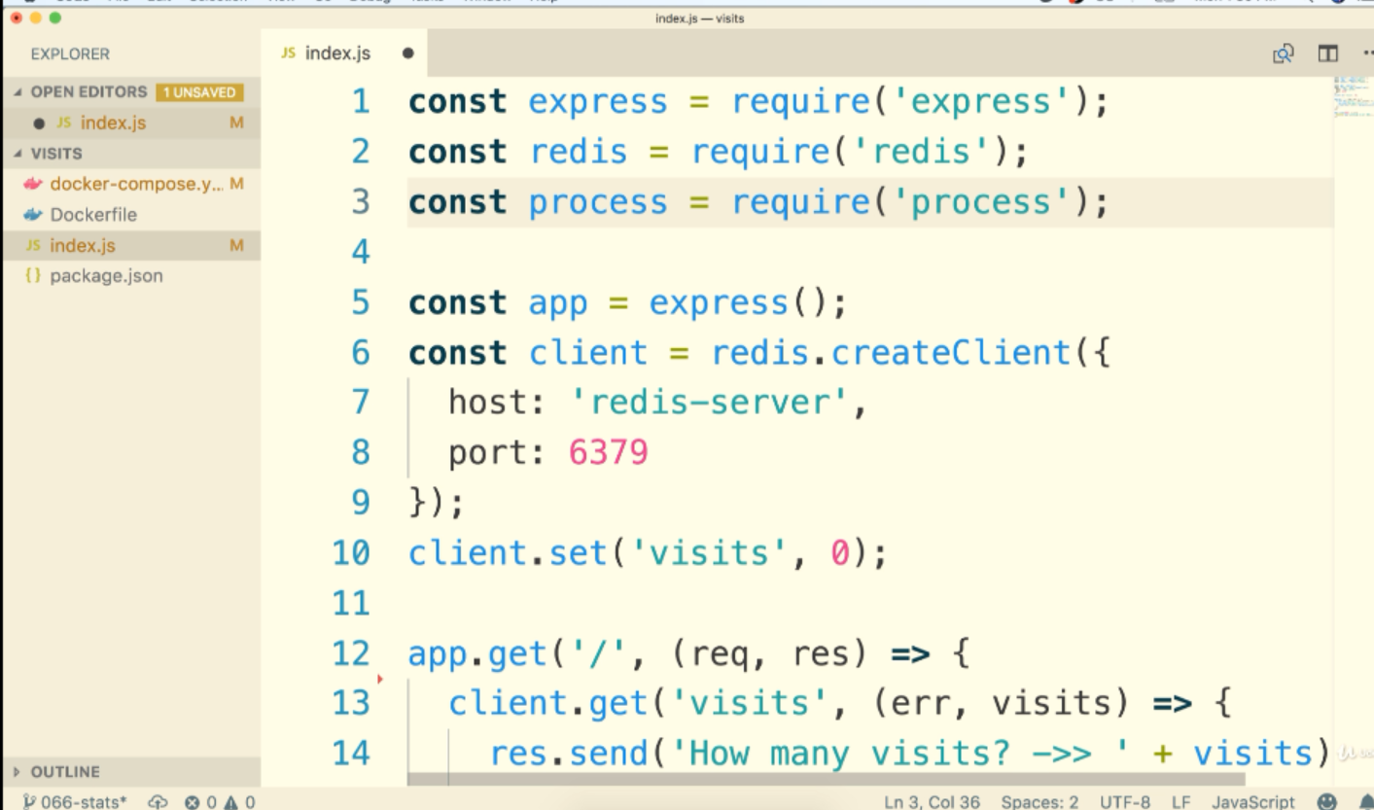

Add line:13:

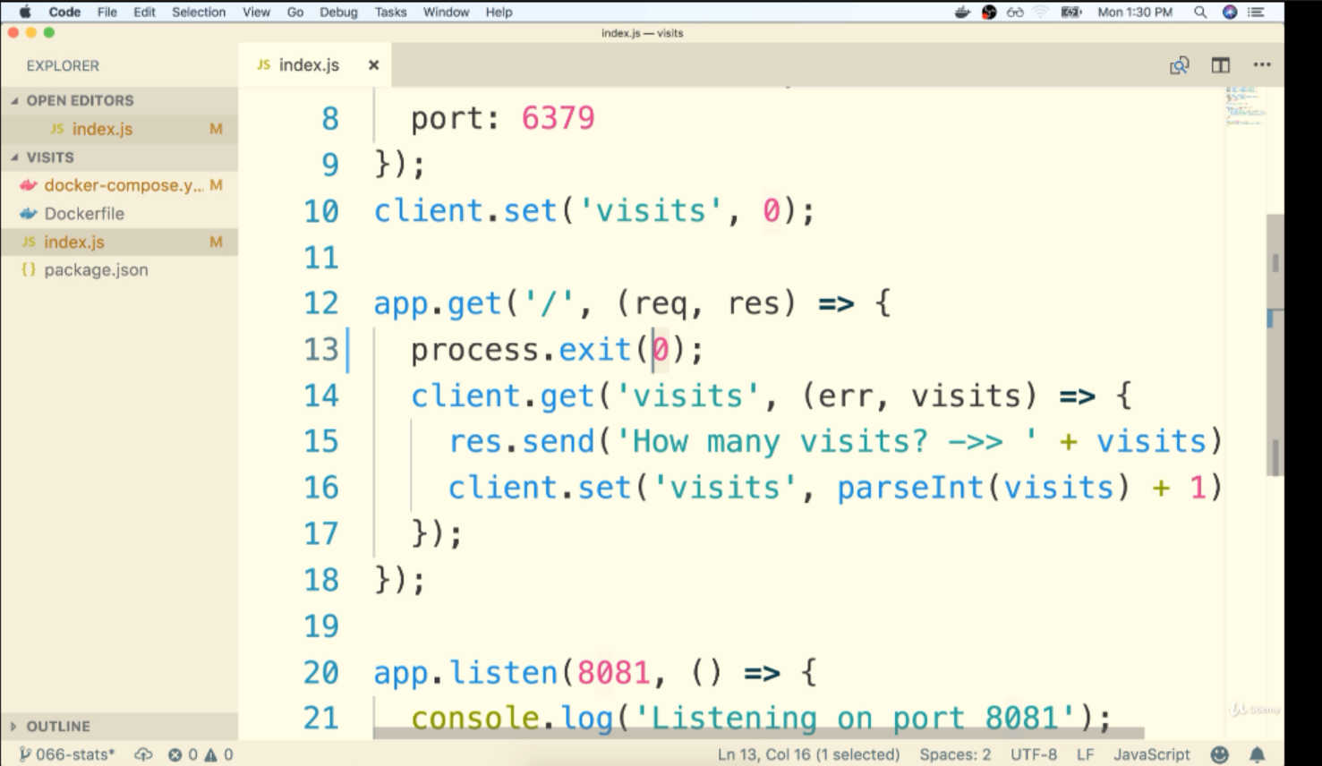

We are crashing the server when we try to enter the route.



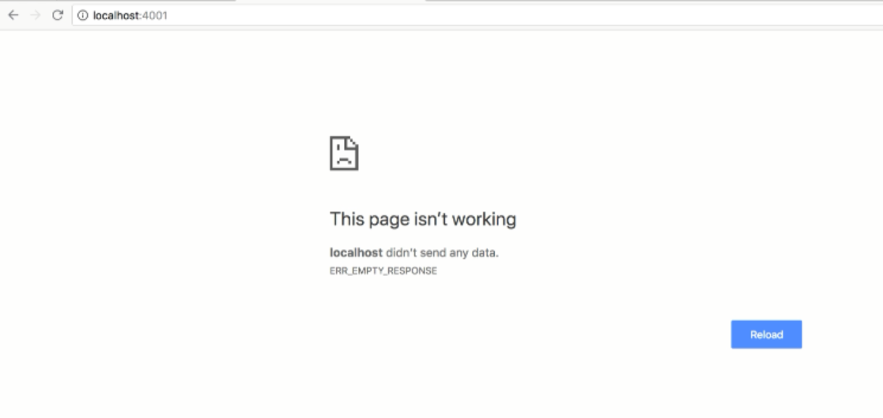

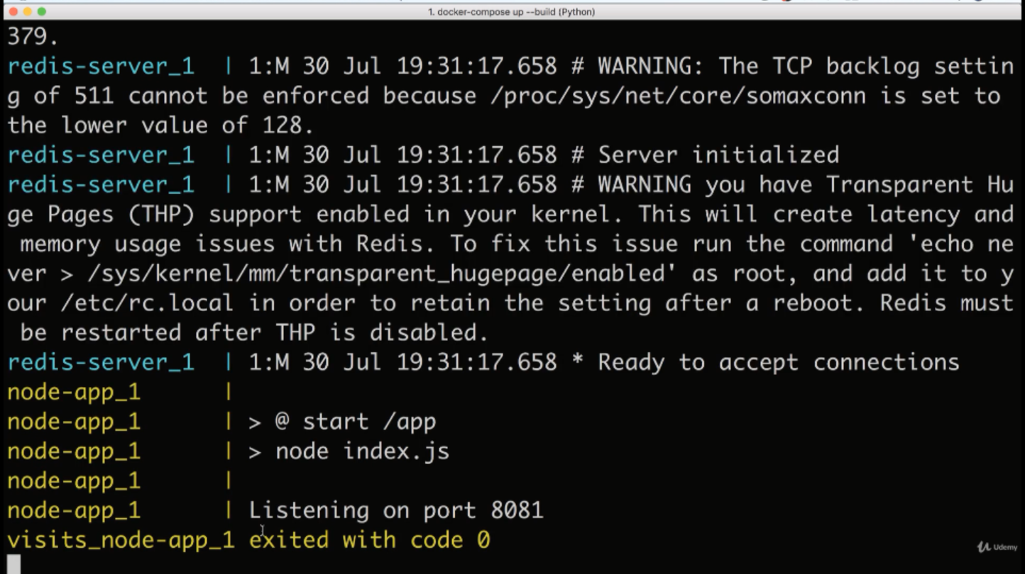

Node server got crashed so that now only one server is running

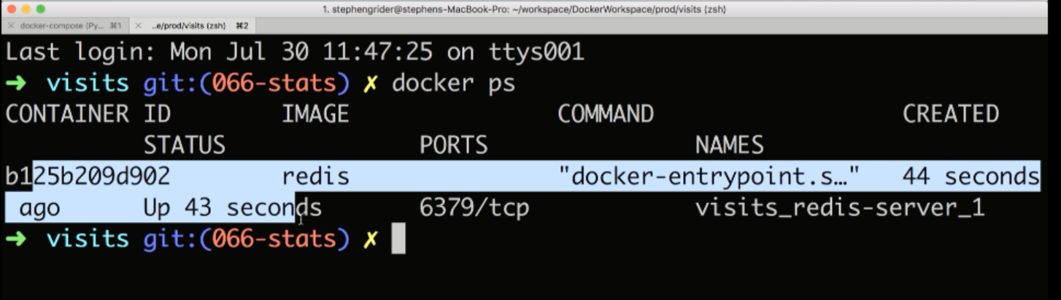

V—60:(Automatically Container Restarts):

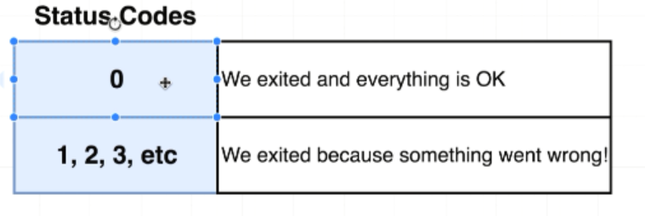

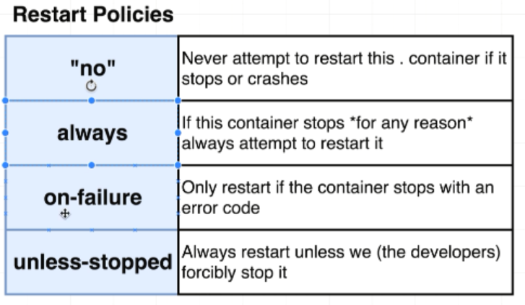

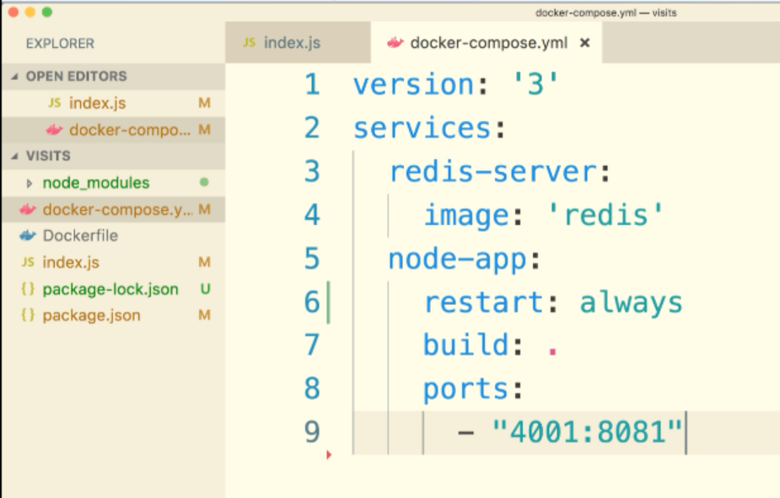

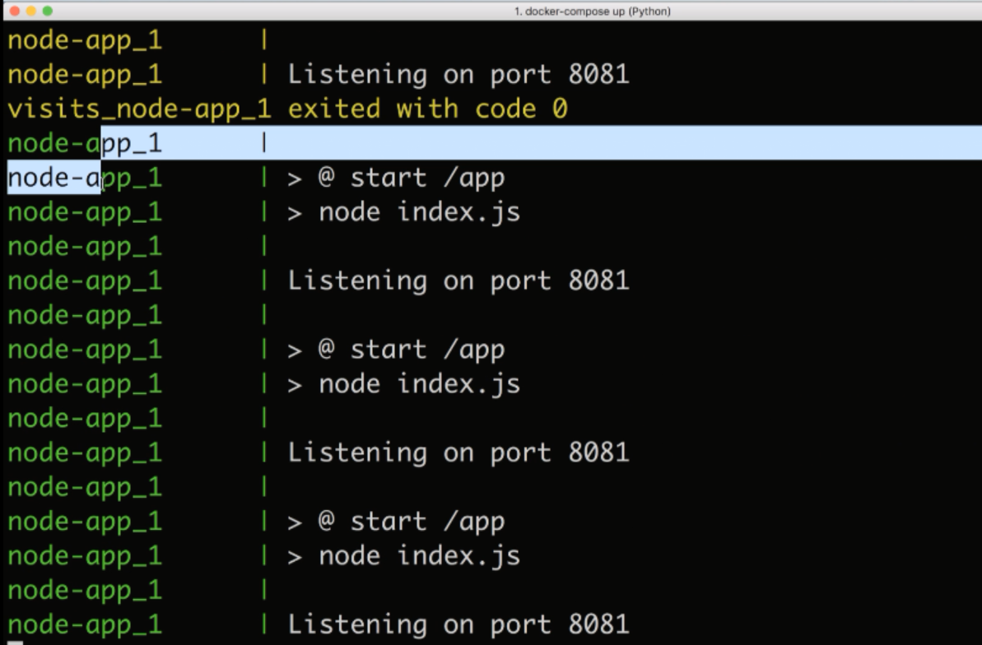

V—61:(Container Status with Docker Compose):

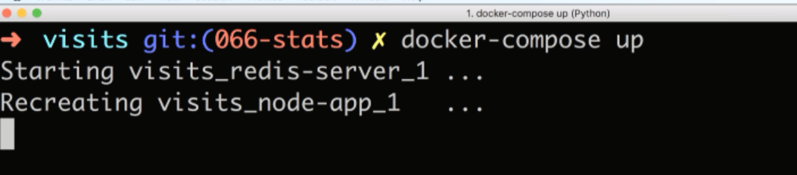

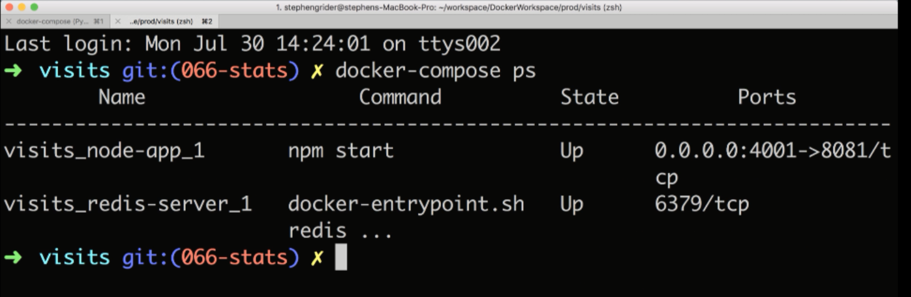

If you give docker-compose ps command. It will search for the docker-compose file and read that file and it will try to find all the running containers on your local machine that belong essentially to that docker-compose file. If you run docker-compose ps command from any other directory we will get an error message.

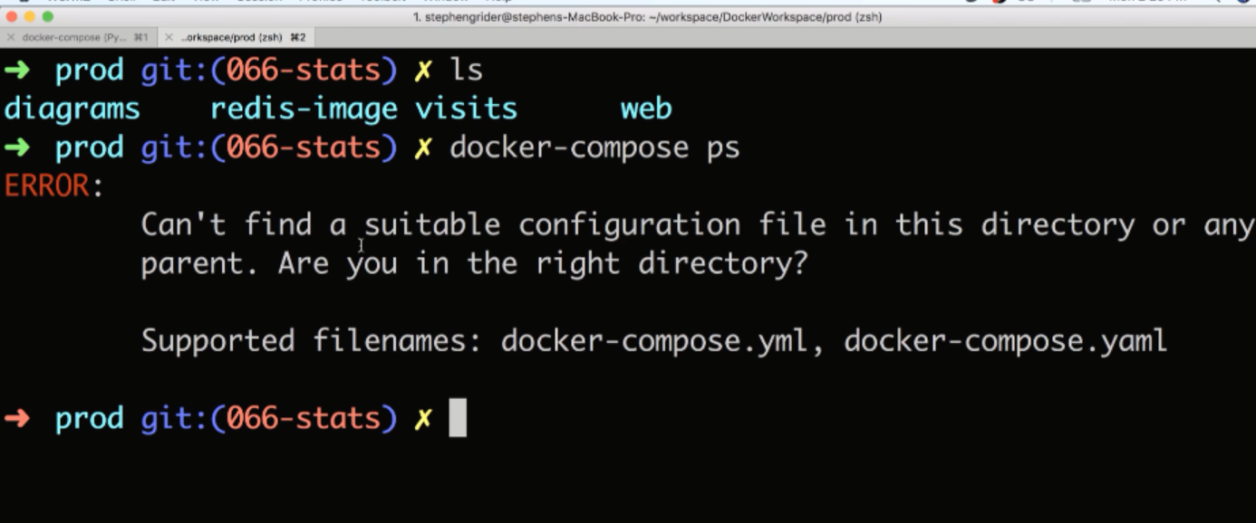

Starting docker in AWS EC2 instance:

sudo yum -y update

sudo yum install -y docker

sudo service docker start

sudo usermod -a -G docker ec2-user

docker images

docker ps -🡪 for running container

docker ps -a 🡪 for all containers

sudo service docker stop